










ine
ue
e iver

  Satyam Sahu (2201220130097)
e
Shïvam Chauhan (2201220130102)

ide: - Prof. Ajay Kr. Srivastava
oordinator: - Er. Shilpi Khanna












OJECT OBJECTIVE

velop a secure web and mobile-based platform for tep fuel booking with user authentication and online ent integration.

plement a real-time order tracking and delivery gement system to ensure efficient and transparent fuel ution.
 sign an admin dashboard to manage users, orders, ery agents, while ensuring safety compliance and fuel ty monitoring.













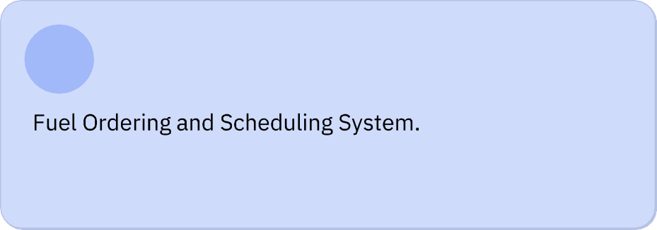











ORK COMPLETED


ntend Ui Development (User &
 min Panel)

er Authentication & Authorization
 odule
elivery Tracking Module











DIFFICULTIES
 ty in integrating real-time GPS tracking


nt gateway sandbox configuration


ing fuel safety compliance and




 ory guidelines in system design.












